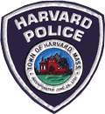
Harvard Public Safety Building
40 Ayer Road, Harvard
Drug Take Back Box
CAN NOT ACCEPTED the following items:
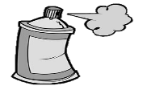
AEROSOL CANS

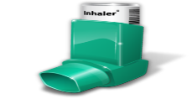
INHALERS
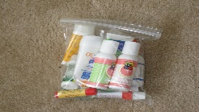
LIQUIDS
LOTIONS

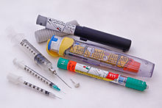
EPI PENS
NEEDLES
SHARPS
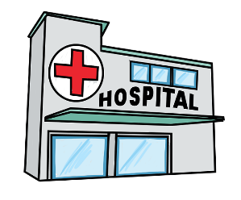
MEDICATION FROM Hospitals,
BUSINESSES OR CLINICS

If you have any questions, Please call the business line of the Police Department
978-456-8276

